# FACULTY -BIODATA

|  |  |  |  |  |  |  |  |  |  |  |  |  |
| --- | --- | --- | --- | --- | --- | --- | --- | --- | --- | --- | --- | --- |
| **Department** | D.Pharmacy | | | | | | | | | | |  |
| **Designation:** | Lecturer | | | | | | | | | | |
| **Name of Faculty:** | Mrs. Kadam Puja Amol | | | | | | | | | | |
| **Date of Birth:** | 24/07/1991 | **Date of Joining**: | | | | 01/12/2022 | | | | | |
| **Qualification with Class/Grade** | **UG** | **PG** | | | | **Ph.D.** | | | | | |
| Distinction | - | | | | - | | | | | |
| **Area of Specialization:** | - | | | | | | | | | | | |
| **Total Experience in Years**: | **Teaching** | | | **Industry** | | | | | | | **Research** | |
| 03 years | | | 01 year | | | | | | | - | |
| **Mobile No:** | 7767887296 | | | **E-mail ID:** | | | | | | Pak_pharm@yes.edu.in | | |
| **Number of PhD, M.Tech , B.Tech Project Guided** | **UG: -** | | | | | | **PG: -** | | | | | **Ph.D. : -** |
| **Professional Society Memberships** | - | | | | | | | | | | | |
| **Paper Published in Journals** | National: 03 | | | | | | | International: 00 | | | | |
| **Paper Presented in Conferences** | National: - | | | | | | | International: - | | | | |
| **Books/Chapters/ Patents / Copy rights Published** | Books: - | Chapters:- | | | | | | Patents: | | | | Copyrights: - |
| **STTPs, FDPs, Workshops attended** | STTPs: | | | | FDPs: 04 | | | | | | Workshops: 02 | |
| **Webinars & Seminars attended** | Webinars: - | | | | | | | | Seminars: - | | | |
| **STTP, FDP,Webinar& Seminar conducted** | STTP: - | | FDP: - | | | | | Seminar: - | | | | Webinar: - |
| **Resource Person Work Details** | - | | | | | | | | | | | |
| **NPTEL/Swayam/NITTR/MOOC/ Other courses** | - | | | | | | | | | | | |
| **Awards/Recognitions** | - | | | | | | | | | | | |
| **Consultancy Activities** | O - | | | | | | | | | | | |
| **Google Scholar Link** | - | | | | | | | | | | | |
| **Google Site/Website link** | - | | | | | | | | | | | |

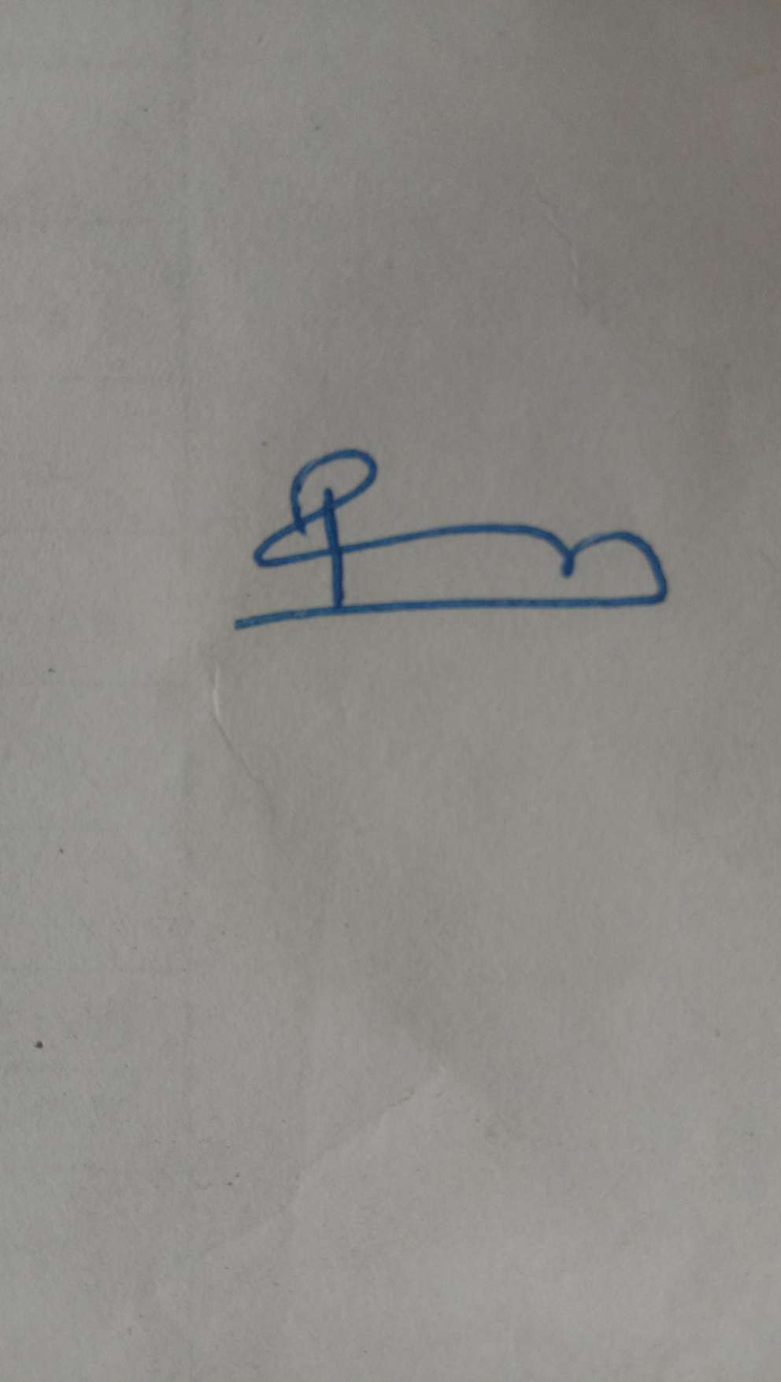

**Name & Signature of Faculty**

Mrs. P. A. Kadam