FACULTY - BIODATA
Department | B. Pharmacy |  |  |  |  |  |  |  |  |  |  | 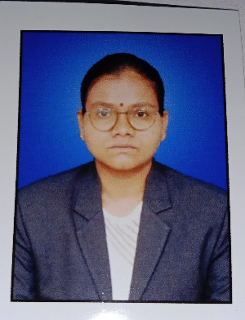
Designation: | Assistant Professor
Name of Faculty: | Miss. Waydande trupti mallhari
Date of Birth: | 27/07/1999 |  | Date of Joining: |  |  | 11/08/2025
Qualification with Class/Grade | UG |  | PG |  |  | Ph.D.
 | 71.66% |  | 8.04 |  |  | -
Area of Specialization: | Pharmaceutics
Total Experience in Years: | Teaching |  |  | Industry |  |  |  |  |  |  | Research
 | 1 |  |  | 1 |  |  |  |  |  |  | 0
Mobile No: | 9607439477 |  |  | E-mail ID: |  |  |  |  |  | lwaydandetrupti_pharm@yes.edu.in
Number of PhD, M.Pharm , B.Pharm Project Guided | UG: 2 |  |  |  |  |  | PG: 0 |  |  |  |  | Ph.D.:0
Professional Society Memberships | Pharmacy Council of India
Paper Published in Journals | National: 0 |  |  |  |  |  |  | International: 2
Paper Presented in Conferences | National: 0 |  |  |  |  |  |  | International: 2
Books/Chapters/ Patents / Copy rights Published | Books: |  | Chapters:- |  |  |  |  | Patents: |  |  |  | Copyrights: -
STTPs, FDPs, Workshops attended | STTPs: |  |  |  | FDPs: |  |  |  |  |  | Workshops:
Webinars & Seminars attended | Webinars: |  |  |  |  |  |  |  | Seminars:
STTP, FDP,Webinar & Seminar conducted | STTP: | FDP: |  |  |  |  |  | Seminar: |  |  |  | Webinar:
Resource Person Work Details | Assistant Prof. at YSPMS Yashoda Technical Campus
NPTEL/Swayam/NITTR/MOOC/ Other courses | NA
Awards/Recognitions | NA
Consultancy Activities | NA
Google Scholar Link | https://scholar.google.com/citations?view_op=list_works&hl=en&user=fGBgmuQAAAAJ
Google Site/Website link



Name & Signature of Faculty

