Yashoda Shikshan Prasarak Mandal’s
Yashoda Technical Campus, Satara.


FACULTY -BIODATA

Department | Pharm D |  |  |  |  |  |  |  |  |  |  | 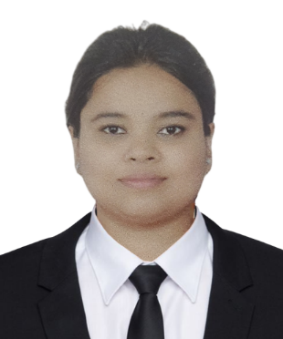
Designation: | Assistant Professor
Name of Faculty: | Dr.Gat Roshani Ramdas
Date of Birth: | 26/06/2000 |  | Date of Joining: |  |  | 12/07/2025
Qualification with Class/Grade | UG |  | PG |  |  | Ph.D.
Qualification with Class/Grade |  |  | I
Area of Specialization:
Total Experience in  Years: | Teaching |  |  | Industry |  |  |  |  |  |  | Research
Mobile No: | 8805105667 |  |  | E-mail ID: |  |  |  |  |  | roshanigat_pharm@yes.edu.in
Number of PhD, M.Pharm , B.Pharm Project Guided | UG: |  |  |  |  |  | PG: |  |  |  |  | Ph.D. :
Professional Society
Memberships
Paper Published in Journals | National: 1 |  |  |  |  |  |  | International:1
Paper Presented in  Conferences | National: |  |  |  |  |  |  | International:
Books/Chapters/ Patents  / Copy rights Published | Books: |  | Chapters:- |  |  |  |  | Patents: |  |  |  | Copyrights: -
STTPs, FDPs, Workshops attended | STTPs: |  |  |  | FDPs: |  |  |  |  |  | Workshops:
Webinars & Seminars attended | Webinars: 3 |  |  |  |  |  |  |  | Seminars: 2
STTP, FDP,Webinar &  Seminar conducted | STTP: | FDP:1 |  |  |  |  |  | Seminar:2 |  |  |  | Webinar:1
Resource Person Work Details
NPTEL/Swayam/NITTR/ MOOC/ Other courses | SWAYAM Courses
Awards/Recognitions
Consultancy Activities
Google Scholar Link | https://scholar.google.com/citations?hl=en&user=iWdywvIAAAAJ&scilu=&scisig=ACUpqDcAAAAAaIhyFtCKUzM1nXKQCSuIvqIYj58&gmla=AH8HC4zCkhaYjI3zHK4jB7hvUjClPejLn61ESwLdT1lXvYKIxbE0wbbgEOz0fGtxVCdT0Ev61vFlALdxxY4x9frIORclsJD-SWElkztLviM3&sciund=14238181358516417306
Google Site/Website link | https://scholar.google.com/citations?hl=en&user=iWdywvIAAAAJ&scilu=&scisig=ACUpqDcAAAAAaIhyFtCKUzM1nXKQCSuIvqIYj58&gmla=AH8HC4zCkhaYjI3zHK4jB7hvUjClPejLn61ESwLdT1lXvYKIxbE0wbbgEOz0fGtxVCdT0Ev61vFlALdxxY4x9frIORclsJD-SWElkztLviM3&sciund=14238181358516417306


Name & Signature of Faculty
Roshani R. Gat

