FACULTY -BIODATA
Department | Pharmaceutical Chemistry |  |  |  |  |  |  |  |  |  | 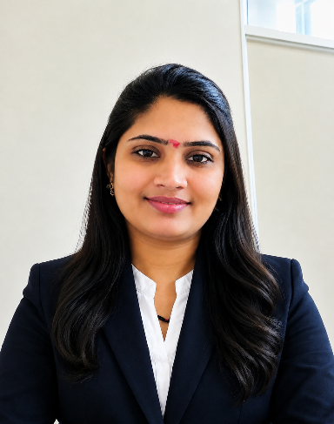
Designation: | Associate Professor
Name of Faculty: | Sandhya Pankaj Kadam
Date of Birth: | 19/07/1989 |  | Date of Joining: |  |  | 04/05/2022
Qualification with Class/Grade | UG |  | PG |  |  | Ph.D.
Qualification with Class/Grade | 1st class |  | 1st class |  |  | Pursuing
Area of Specialization: | Quality Assurance
Total Experience in Years: | Teaching |  |  | Industry |  |  |  |  |  |  |  | Research
Total Experience in Years: | 4 years 5 months |  |  | 2 years 2 months |  |  |  |  |  |  |  | -
Mobile No: | 9172995247 |  |  | E-mail ID: |  |  |  |  |  | sandhyashinde9999@gmail.com
Number of PhD, M.Pharm , B.PharmProject Guided | UG: 20 |  |  |  |  |  | PG:-- |  |  |  | Ph.D. :--
Professional Society Memberships | -
Paper Published in Journals | National: |  |  |  |  |  |  | International: 30
Paper/Poster Presented in Conferences | National: -1 |  |  |  |  |  |  | International: -1
Books/Chapters/ Patents / Copy rights Published | Books: -1 |  | Chapters:- |  |  |  |  | Patents: 1 |  |  | Copyrights: -
STTPs, FDPs, Workshops attended | STTPs: |  |  |  | FDPs: 1 |  |  |  |  |  |  | Workshops: 1
Webinars & Seminars attended | Webinars: 12 |  |  |  |  |  |  |  | Seminars:
STTP, FDP,Webinar& Seminar conducted | STTP: | FDP: |  |  |  |  |  | Seminar: |  |  | Webinar:
Resource Person Work Details | -
NPTEL/Swayam/NITTR/MOOC/ Other courses | -
Awards/Recognitions | -
Consultancy Activities | -
Google Scholar Link | https://scholar.google.com/citations?user=qKUqr5sAAAAJ&hl=en
Google Site/Website link | https://sites.google.com/yes.edu.in/mrssandhyapkadam/home


Name & Signature of Faculty
Sandhya Pankaj Kadam

